**View:**The view is Database object or virtual table. View physically does’t exist in database that’swhy it is called as virtual table. The view is created from table[s] those table is also called as base table[s].

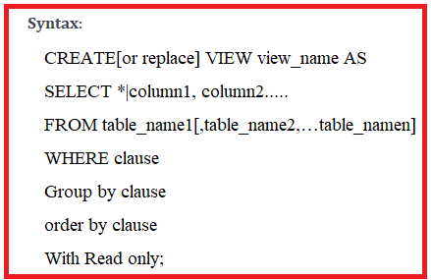

Note:-1. In all databases whenever we are creating view then automatically view definition are permanently store in database. In ‘oracle’ View definition is stored in “user_views” data dictionary.

2.Oracle 11g onwards, view can be created with out base table.

3.Once View created, we can’t add new column to existing view.

4.Once view created, we can’t drop & modify the column from existing view.

5.Once view created, we can’t rename the existing column in view.

6.1) View Types:-There are two types of view.

a) simple view.

b) complex view.

1)simple view:- The simple view is created only from one base table.

Base table:Employee

|  |  |  |  |  |
| --- | --- | --- | --- | --- |
| Eno | Ename | Sal | Desig | experience |
| 1 | Vasavi | 25000 | Assoc.prof | 18 |
| 2 | Suresh | 24000 | Asst.prof | 14 |
| 3 | Venkatesh | 18000 | Lecturer | 10 |
| 4 | Gopi | 17000 | Asst.prof | 13 |
| 5 | Maqbool | 26000 | Assoc.prof | 14 |
| 6 | Keerthi | 14000 | Asst.prof | 12 |
| 7 | Reddy | 15000 | Asst.prof | 30 |

Example:-

Sql> create view Asst.prof as select eid,ename,sal,experience from Employee where design=’asst.prof’;

Where employee is base table name.

View name is Asst.prof.

SQL> select * from Asst.prof;

|  |  |  |  |
| --- | --- | --- | --- |
| 2 | Suresh | 24000 | 14 |
| 4 | Gopi | 17000 | 13 |
| 6 | Keerthi | 14000 | 12 |
| 7 | Reddy | 15000 | 30 |

DML Operations On Simple View in Oracle :

In oracle we can also perform DML operation through simple view to base table based on following rectrictions.

1. If a simple view definition having Group Function,Group by clause,row num, distinct , Set operators, joins then we can’t perform DML operation through simple view to base table.
2. We must include Not Null column, primary key column into view then only we can perform “insertion operation” through simpleview to base table. Otherwise oracle server returns an error.

2.Complex view:- The complex view is create from more than one base table.

BaseTable1:Employee.

BaseTable2:Works-In

|  |  |  |
| --- | --- | --- |
| Eid | Did | Date |
| 1 | 001 | 2010 |
| 2 | 001 | 2005 |
| 3 | 001 | 2012 |
| 4 | 001 | 2011 |
| 5 | 002 | 2014 |
| 6 | 002 | 2015 |
| 7 | 002 | 2018 |

Sql> create view MCA as select e.eid, e.ename, e.sal, e.desig,e.experience from employee e , works-in w

Where e.eid=w.eid;

Where base tables are Employee and works-in.

View name is MCA.

|  |  |  |  |  |
| --- | --- | --- | --- | --- |
| 1 | Vasavi | 25000 | Assoc.prof | 18 |
| 2 | Suresh | 24000 | Asst.prof | 14 |
| 3 | Venkat | 18000 | Lecturer | 10 |
| 4 | Gopi | 17000 | Asst.prof | 13 |

DML Operations On Complex View in Oracle :

Generally, in all database systems we can not perform DML operations through “complex view” to base tables. In oracle when we trying to perform DML operations through “complex view” to base table then some table columns are affected and some other are not affected. In oracle, if we want to view affected,unaffected columns then we are using “user_updatable_columns “Data dictionary.

SQL> select column_name,updatable from user_updatable_columns where table_name=”v5”;

Note:Generally in oracle , we can’t perform DML operations through complex view to bDase table. To overcome this problem oracle 8.0 introduced INSTEAD of trigger in pl/sql.

6.2)

A) Advantages of Views:-

1.Views are usually virtual and occupy no space.

2. view can be used to hide some data from base table[s].

B) Disadvantages of views:-

1.when the table is dropped,view is not accessible.

6.3)Materialized view:-

Syntax: create materialized view view_name

[refresh complete|fast on demand|commit] as Select Statement.

Difference between Materialized view and normal view.

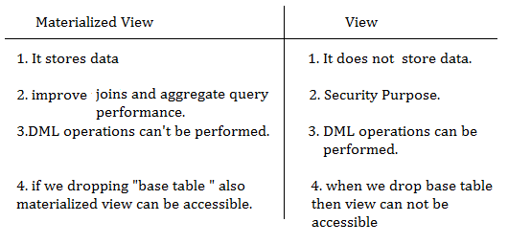

Note:-

1.Whenever we are creating Materialized view then automatically materialized view definition is stored in “user_mviews” data dictionary.

2.In oracle one of materialized view base table must have primary key then only we can create materialized view , otherwise oracle server returns error.

But oracle11g onwards ,we can create materialized view when base table does not have primary key.

Q)How Materialized view improves Query performance?

A) Whenever user requesting Materialized view by using select statement then orale server each and every time retrieves data from Materialized view. In this case base table is not affected, that’s why maretialized view improves performance of query.

6.3.1) Materialzed view Types:- in oracle having two types of materialized view.

a)Complete refresh materialized view.

b)Fast refresh materialized view/Incremental Refresh Materialized view

A)complete refresh materialized view:In oracle by default materialized view is complete refresh materialized view. This type of view does not give more performance when we are refreshing materialized view number of times, because this materialized view whenever we are refreshing materialized view internally row id are recreated even we are not modifying data in base table also.

B)Fast refresh Materialized view: This type of view gives more performance .Because RowID are never changed when we refreshing materialized view number of times also.

6.3.2)When we refresh materialized view its synchronized database on basetable. In Oracle we can refresh materialized view in 2 ways:

a)Manually.

b)Automatically.

a)Manually:-If we want to refresh materialized view then we are using refresh procedure from dbms_mview package.

Syntax: exec dbms_mview.refresh(“materialized view name”);

b)Automatically:-we can also refresh materialized view without using “dbms_mview” package. This method is also called as “on commit” method.

Example:

-------------

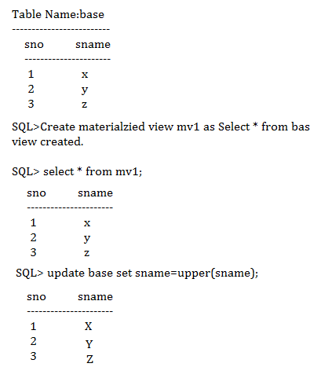

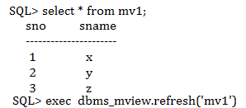

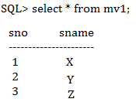

Syntax:- To remove the materialized view.

Drop materialized view view_name;

**6.4)Read Only Views**: when a views having with read only clause then those types of view is called read only views.

Example:

SQL> create view Asst.prof

As select * from employee

Where design=’asst.prof’

With read only;

6.5)Force View:-we can create a view with out base table. This type of view is called force view.

Syntax:

Create or replace force view view_name

As

Select Query;

Sql> view_name created with compilation errors.

Later create base table.After creating the base table,we should do the recompile the view.

Sql> alter view view_name compile;